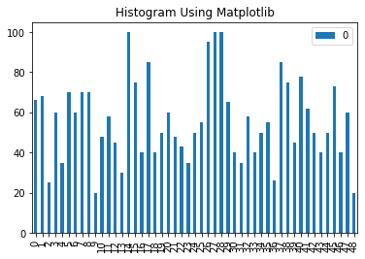

Histogram of mid-term: note that the data are shuffled so they are not in order.

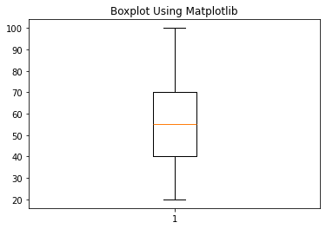

count 49.000000

mean 56.081633

std 20.532329

min 20.000000

25% 40.000000

50% 55.000000

75% 70.000000

max 100.000000